**Faculty Profile Template**

1. **Basic Information**

* **Name**: Upasana Khadatkar
* **Designation**: Asst. Professor
* **Department/School**: CSE
* **Institution Name**: SSIPMT
* **Email ID**: u.khadatkar@ssipmt.com
* **Contact Number**: 9770554948
* **Photograph**: 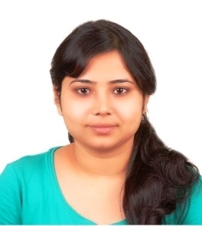

1. **Educational Qualifications**

|  |  |  |  |
| --- | --- | --- | --- |
| **Degree** | **Specialization** | **Institution** | **Year of Completion** |
| UG | IT | RITEE | 2009 |
| PG | CSE | RITEE | 2011 |
| Ph.D. | NA | NA | NA |
| Others | *(if applicable)* |  |  |

1. **Teaching & Research Experience**

* **Total Teaching Experience**: 04
* **Industry Experience**: NA
* **Research Experience**: NA

1. **Courses Taught**

* Fundamental of Computing
* Programming in C

1. **Research Interests / Specialization**

* Image Processing

1. **Publications (Last 5 Years)- 02**
2. **Research Guidance**

|  |  |  |
| --- | --- | --- |
| **Level** | **Awarded** | **Ongoing** |
| Ph.D. | NA | NA |
| PG | NA | NA |

1. **Awards & Recognitions**

NA

1. **Administrative Roles**
2. **Professional Memberships**

NA

1. **Web Presence**

NA